JOINING INSTRUCTIONS

GENERAL

- The Commander and all the personnel welcome you to the 2 Canadian Division Training Centre (2 Cdn Div TC). The instructions in this document apply to all military members -trainees, managers and instructors- who will be taking part in the 2 Cdn Div TC autumn (TAII) or winter (THII) individual training. It is important that you follow these instructions so as to ensure that you have all the documents and equipment that you will need and which will be useful to you during your stay.

PURPOSE
- The purpose of this directive is to familiarize you with the 2 Cdn Div TC’s organization, rules and procedures, and to provide you with information about the services available at the Valcartier Base.

JOINING INSTRUCTIONS
- Annual Program:
  - all members must report on the date and time indicated in the message. A course representative will be on site to greet you and direct you to your quarters. The representative will give you instructions relating to your course;
  - if, for exceptional reasons, you are unable to be there on time, you must notify the staff member on duty by calling (418) 844-5000, extension 7255, or the Unit Chief Clerk at (418) 844-5000, extension 5649/6227.
TRANSPORTATION
- By air. Members travelling by commercial airline will arrive at the Quebec City airport. They will need to take a taxi, and must make sure they get a receipt, which they will have to submit with their claim. RTC (Réseau de transport de La Capitale) buses do not serve the airport. A taxi from the airport to the Valcartier Base costs on average about $45.
- By train. Members travelling by train will arrive at the Intermodal Station in downtown Quebec City (formerly the Gare du Palais). RTC buses do not serve the Station. A taxi from the Intermodal Station costs on average about $55.
- By car. Members using their personal vehicles must have the following documents on hand at all times:
  - proof of insurance;
  - valid automobile registration;
  - valid driver’s license;
  - directions: the 2 Cdn Div TC, a lodger unit on the Valcartier base, is located 20 kms North-East of Quebec City via Henri IV Boulevard North.
- Trainees can park in the parking area behind the CSEM-1 building.

ARRIVAL PROCEDURES – ADMINISTRATION
- You must have the following documents with you:
  - TAII/THII:
    - all members who are not from the Valcartier Base administrative region must have a claim form (DND 99);
    - an ID card (CAFIB 20);
    - if applicable, a duly completed and signed CF 100 form;
    - for those who have a military driver's licence, their DND 404;
    - students having an exemption for wearing a beard must bring with them their medical updated paper;
    - students must have a legible copy of the DND 279, Force program, or have the documents signed by their commander to prove they successfully passed the Land Force Command Psysical Fitness Standard LFCPFS (13 kms) or Test FORCE. Students who present themselves for training and that will not be physically and medically fit or do not have the above mentioned documents will be returned to their unit.
    - Candidates who will arrive for the PLQ-I or PLQ-A need to have completed the Gender Based Analysis Plus (GBA Plus) qualification (with proof) as described in CANFORGEN 154/16 CMP 074/16 241553Z Aug 16.

ANNUAL LEAVE MANAGEMENT
- Leave Authorization (CF 100):
  - The member's home unit is responsible for managing annual leave. However, annual leave management becomes more complicated when members are assigned to duties outside their home unit. To avoid any ambiguity, members employed as instructors or trainees at the 2 Cdn Div TC during the period from January to March must make sure they have taken all their annual leave prior to the start of the duty or course. It is, however, recommend that members keep five days of annual leave if they plan to take time off for March break. No leave will be granted during the course. No expenses will be authorized for members wishing to return home. The same policy applies to members from outside the region.
  - No vacation for the trainees will be accepted during the course, and no expense will be allowed to return to their residence. For those arriving from outside, the same policy will be applied.

BAGGAGE
- Members should bring their baggage with them or have it sent (prepaid) well enough in advance to ensure that it arrives before the start of the course. Baggage should be labelled as follows:
SN (last three digits only), rank, surname and initials
Course number and name
2 Canadian Division Training Centre
PO Box 1000, Stn Forces
Courcelette (QC) G0A 4Z0
- Students must have all their personal equipment according to the joining instructions. No time period will be allocated to fetch the missing equipment.
- Experience has shown that baggage sent in advance does not always arrive at the Valcartier Base before the start of the course. Trainees should therefore try to bring their baggage with them, if possible. Additional baggage requests should be made in accordance with regulations.

OPHTHALMOLOGICAL EXAM – LASER
- Given the increased use of laser range finders and simulators at the 2 Cdn Div TC, ophthalmological exams are mandatory (personnel exposed to laser beams) as per CFMO 27-13. All personnel –including back-up staff– taking the basic sniper course must have had an ophthalmological exam prior to arriving at the 2 Cdn Div TC.
- Trainees taking the course must provide certification that they have had an ophthalmological exam.

REQUIREMENT TO LIVE IN THE QUARTERS
- For the entire duration of the BMQ-L, PP1,PLQ-A , AJLC and IJLC courses, all trainees, including those whose home is in the Valcartier Base geographical region, must reside in the quarters assigned to them. Trainees must also expect to remain in barracks during the first weekend. In the case of the other courses, only trainees from outside the Valcartier geographical region will be given housing upon submitting an application.

SECURITY
- Trainees must have two padlocks with keys to secure their military and personal equipment. The padlocks must be sturdy, i.e., the shackle must be at least 35 mm. You should also avoid having attractive personal items in your possession, such as sound systems, jewelry, etc. The 2 Cdn Div TC is not responsible for the theft or loss of personal items.

SERVICES
- Mailing address. The mailing address is the same as the address for baggage indicated in paragraph 10.
- Pay (for reservists only):
  - weekend courses: attendance sheets (CF 895) will be drawn up, and you will be asked to sign the sheet when you report to your course. It should be noted that the days you attended the 2 Cdn Div TC will appear on your pay cheque, which will be deposited directly in your account at your financial institution;
  - full-time courses: your pay will be calculated by your reserve unit, based on the information provided (by the orderly room). Your pay will be deposited directly in your account at your financial institution.
- Emergency phone number: The numbers where you can be reached at the 2 Cdn Div TC in an emergency are as follows:
  - between 0800 hours and 1630 hours: (418) 844-5000, extension 6227 or 5649;
  - after regular business hours: (418) 844-5000, extension 7255. Cell: (418) 802-0421.
- Community services: The CANEX shopping centre is located near the Valcartier Base married quarters. It includes a supermarket, a department store and a hair salon for men and women. There is also a drug store, a flower shop, a snack bar and a Caisse d'économie affiliated with the Caisses populaires Desjardins, with three bank machines. The supermarket offers dry cleaning and post office services.
- Medical and dental support: Medical and dental support are provided by the Valcartier Health Centre and the 1 Dental Unit. Should there be an emergency outside regular working hours, the 2 Cdn Div TC Duty Officer must be notified immediately. However, you must go to a civilian facility. During regular working hours, the course assistant or any instructors present will take charge in emergency situations.
- Recreational activities: The Valcartier Base boasts excellent sports facilities, to which you have access for a fee if you are not subscribed to the Valcartier Base Sports and Recreation Plan. The following services are not free of charge, unless otherwise indicated: golf course, gym/weight room/hydrogymnastics room (free), indoor (free) and outdoor pools, downhill skiing, arena, hunting and fishing, scuba diving, etc. To get in for free, you need to show a military ID card.

KITCHENS
- NCM Kitchen, Building 505: Located near the quarters, the NCM Kitchen serves meals according to the schedule below.
  - Weekdays:
    - Breakfast from 0600 to 0930 hours;
    - Lunch from 1130 to 1300 hours;
    - Supper from 1630 1830 hours.
  - Weekends and statutory holidays:
    - Breakfast from 0600 0930 hours;
    - Brunch from 1130 to 1300 hours;
    - Supper from 1630 to 1800 hours.
- Warrant Officers’ and Sergeants’ Mess Kitchen
  - Weekdays: Lunch from 1130 to 1300 hours;
  - Breakfast and supper: NCM Kitchen, according to the schedule in paragraph 23b;
  - Weekends and statutory holidays: NCM Kitchen, according to the schedule in paragraph 23b.
- Officers’ Mess Kitchen, Building 511A
  - Weekdays:
    - Breakfast from 0600 to 0930 hours;
    - Lunch from 1130 to 1300 hours;
    - Supper from 1630 to 1800 hours.
  - Weekends and statutory holidays: NCM Kitchen, according to the schedule in paragraph 23b.

MESSES
- In accordance with the regulations (CFAO 27-1), all staff members, managers and instructors shall pay dues for a mess appropriate to their rank for their entire period of employment. In order to ensure rigorous control, the managers of the various messes will be given lists of personnel sorted by rank.

GRADUATION PARADE
- For trainees taking career courses only: To be able to plan the guest list for the graduation ceremony, you will need to know the name, initials and decorations of your Commander, Chief Warrant Officer and the immediate supervising officer responsible for your section/battery/squadron, as in the example below.
Lieutenant-Colonel J.J.J. Rodrigue, CD

Chief Warrant Officer M. R. Morin, MMM, CD

Captain J.R.G. Simoneau

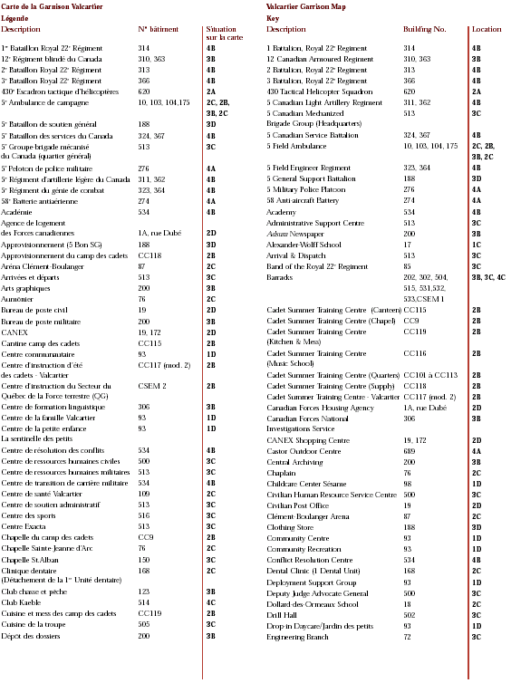
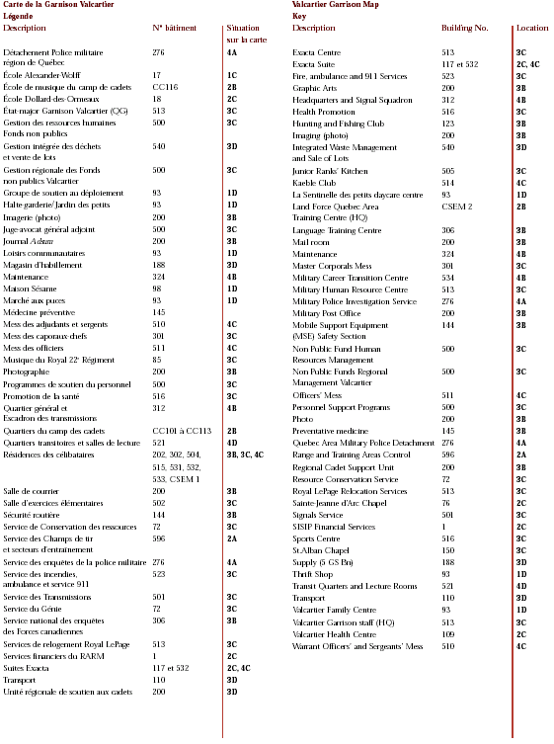
UTILITY VEST

- Charging case:
  - 4 x C7 chargers (top-opening; facing outwards)
- Left utility pouch:
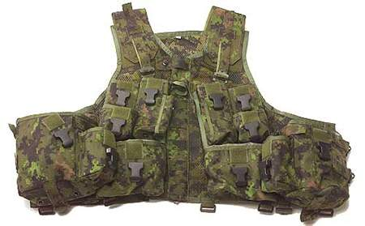
  - 1 x BFA on an operational strap (if not on the C7)
  - 1 x C7 sling (if not on the C7)
4
3
  - 1 x Operational strap (if not on the C7)
  - 1 x Set of ear plugs
1
- Right utility pouch:
  - 1 x Field dressing
8
  - 1 x Pair latex gloves (in Ziploc bag)
  - 1 x KFS (knife, fork and spoon set)
9
- Bayonet scabbard:
  - 1 x Scabbard
  - 1 x Bayonet
- Horizontal water bottle case (on the right):
  - 1 x Stainless steel cup
  - 1 x Plastic water bottle (drinking water)
- Grenade pocket on water bottle case (right side):
  - 1 x Magazine charger
- Belt box charger pocket:
  - 1 x Rain jacket
  - 1 x Cleaning kit (if not in the C7 butt)
  - 1 x Pair of leather combat gloves (Ziploc)
  - 1 x Mag (5th if not on the C7);
- Left grenade pocket (Ziploc):
  - 3 x Camouflage sticks (brown, green, black)
  - 1 x Sunscreen lotion
  - 1 x Lip balm
- Right grenade pocket:
5
  - 1 x Insect repellent
- Gas mask fitted with sling:
  - Main pouch
2
    - Gas Mask
6
    - 1 x gas mask with filter cartridge and blanking plug
7
  - Side pocket
    - 2 x Chemical detector papers
    - 2 x Chemical/neurotoxic agent sensors
    - 1 x Range card
  - Rear pocket
    - 1 x Green case with gas mask googles, if needed
  - Lower pocket
    - 1 x Gas mask with filter cartridge and blanking plug
- Patrol pack (NBC pack), depending on the mission:
  - Notebook, pencil, eraser, pen
  - 1 x Pair of Gore-Tex socks (Ziploc)
  - 1 x Pair of rain pants
  - PT for gym (as per the directive)
  - Equipment, according to the mission

IMPORTANT: Each item must be marked as follows:
- Full surname
- SN (last three digits only)
- The marking should be discreet (the writing must not show when the combat gear is being worn)
- Each piece of equipment must be clean, efficient and in good condition
100

